**Numerical Dataset**

General Information:

1-The Name of Dataset: Houses Prices

2-Number of Classes: 3

3-Number of Their Labels: 234

4-Total Number of Samples: 1460

5-Number of Training : 1168

6-Number of Testing: 292

7-Number of Validation: There is no Validation

Implementation Details:

1. - Feature extraction phase:

* Number of Features: 80
* Name of Features:

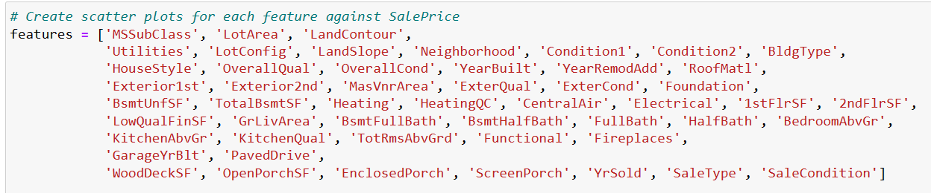

* The Dimension of Features: 80

1. - Yes, Cross-Validation is used in Linear Regression:

* Number of Fold: 3
* Ratio of training / Validation: 2/3

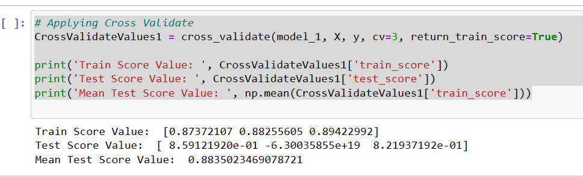

1. - Hyperparameters:

fit_intercept:

Values: [True, False]

Whether to calculate the intercept for the linear regression model.

positive:

Values: [True, False]

Constrain the coefficients to be positive.

Additional Hyperparameters

The code allows for the inclusion of additional hyperparameters in the based on specific requirements. 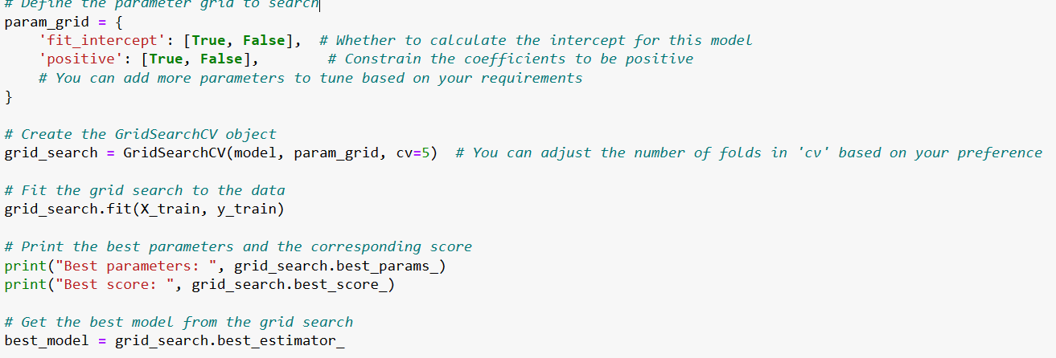

Result Details:

* On Testing Data:

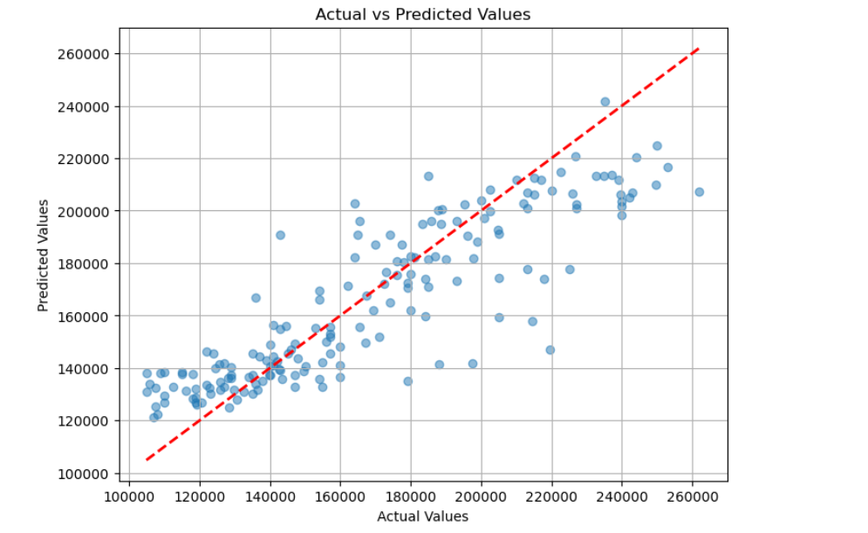

2 – Mean Squared Error

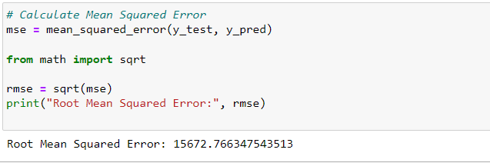

--------------------------------------------------------

**Image Dataset**

1-The Name of Dataset: Malaryia Detection

2-Number of Classes: 2

3-Number of Their Labels: 27558

4-Total Number of Samples: 27558

5-Number of Training : 22046

6-Number of Testing: 5512

7-Number of Validation: There is no Validation

***2-Implementation details:***

***Hyperparameters:***

***3-Result details:***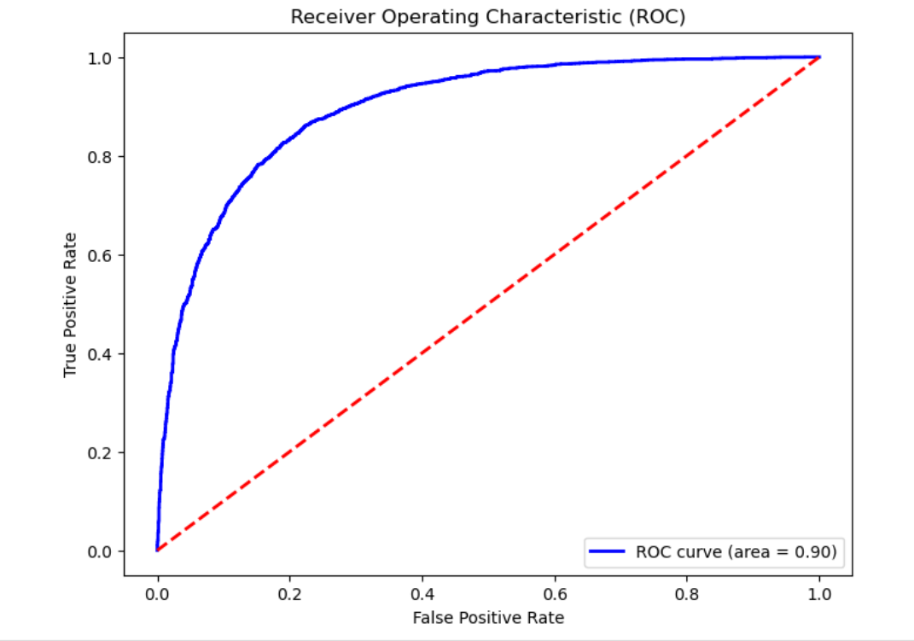

*1-Loss curve:*

*//image of loss logistic*

*//image of knn*

*2-ROC:*

**

3- Confusion Matrix:

